**CONNECT 4**

Submitted in partial fulfilment of the requirements

of the degree of

Bachelor of Engineering in

Artificial Intelligence and Data Science

by

Sheryl Bellary, Nikita Jethani, Anushka Kulkarni, Arya Kurup

under the guidance of Supervisor (s):

Dr. M. Vijayalakshmi

Prof. Ajinkya Valanjoo



**Department of Artificial Intelligence and Data Science**

**Vivekanand Education Society’s Institute of Technology**

**2021-2022**

**Department of Artificial Intelligence and Data Science**

**CERTIFICATE**

This is to certify that **Ms *Anushka Kulkarni, Arya Kurup, Sheryl Bellary and Nikita Jethani*** of Second Year of Artificial Intelligence and Data Science studying under the University of Mumbai have satisfactorily presented the Mini Project entitled **Connect 4** as a part of the MINI-PROJECT for Semester-III under the guidance of **Dr. M. Vijayalakshmi and Prof. Ajinkya Valanjoo** in the year 2021-2022.

Date:

(Name and sign) (Name and sign)

Head of Department Supervisor/Guide

**Department of Artificial Intelligence and Data Science**

**DECLARATION**

We, ***Anushka Kulkarni, Arya Kurup, Sheryl Bellary and Nikita Jethani*** from ***D6AD***, declare that this project represents our ideas in our own words without plagiarism and wherever others' ideas or words have been included, we have adequately cited and referenced the original sources.

We also declare that we have adhered to all principles of academic honesty and integrity and have not misrepresented or fabricated or falsified any idea/data/fact/source in our project work.

We declare that we have maintained a minimum 75% attendance, as per the University of Mumbai norms.

We understand that any violation of the above will be cause for disciplinary action by the Institute.

Yours Faithfully

1.Anushka Kulkarni 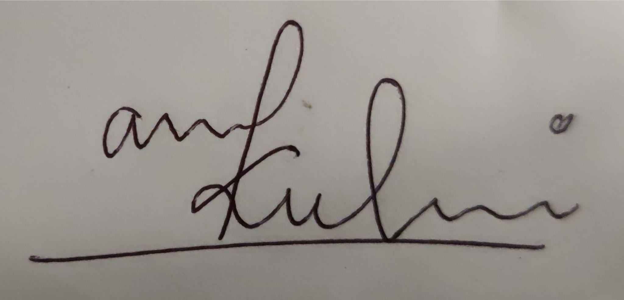

2. Sheryl Bellary 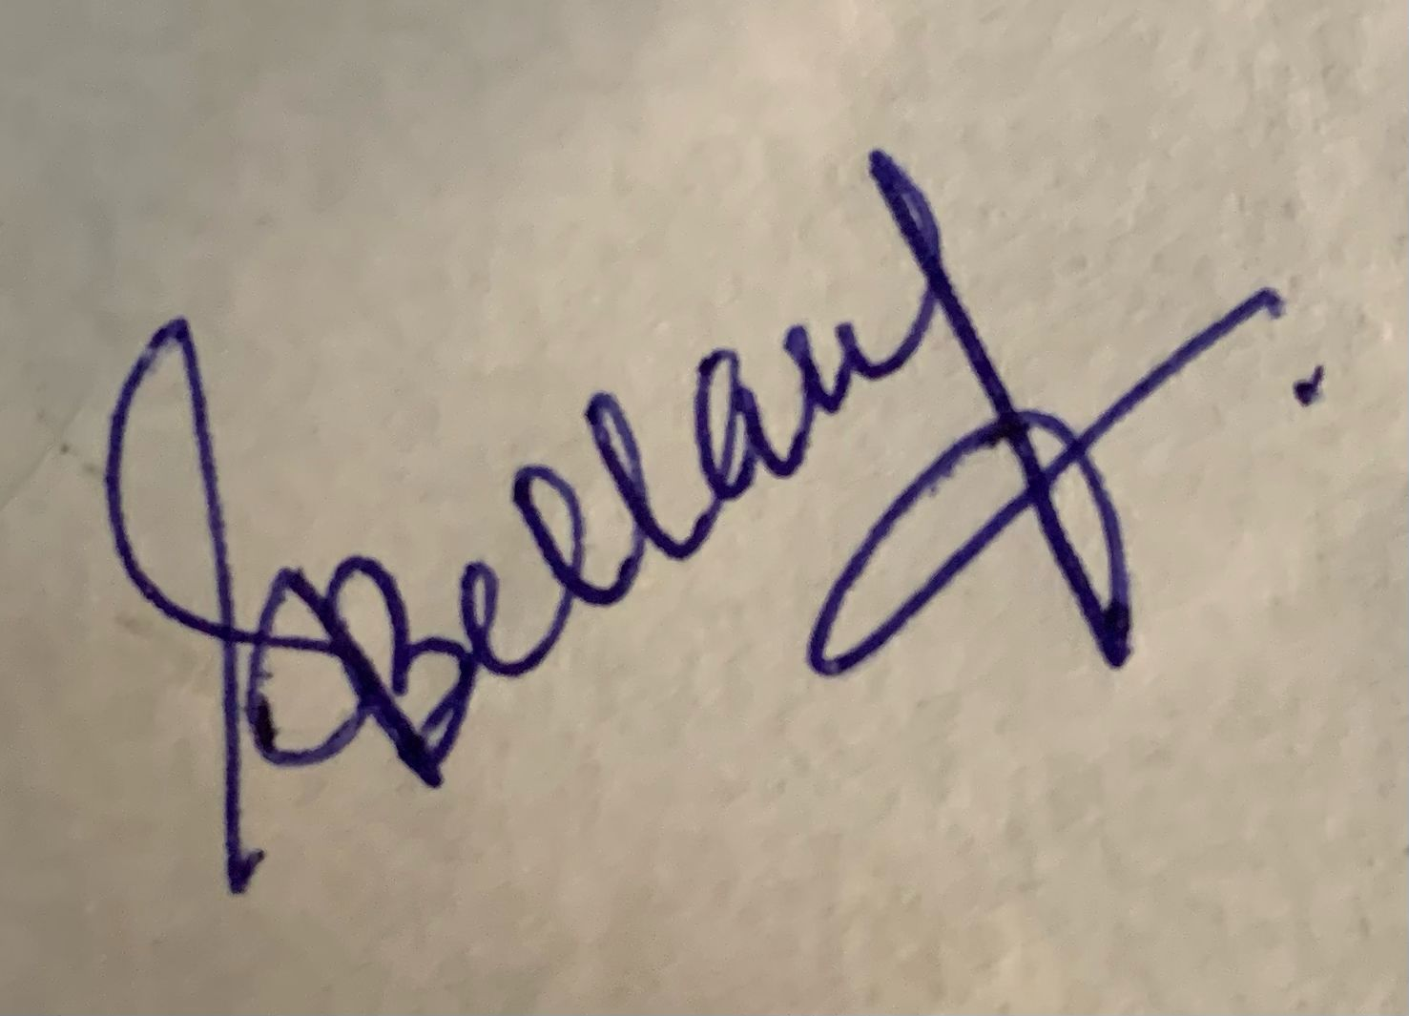

3. Nikita Jethani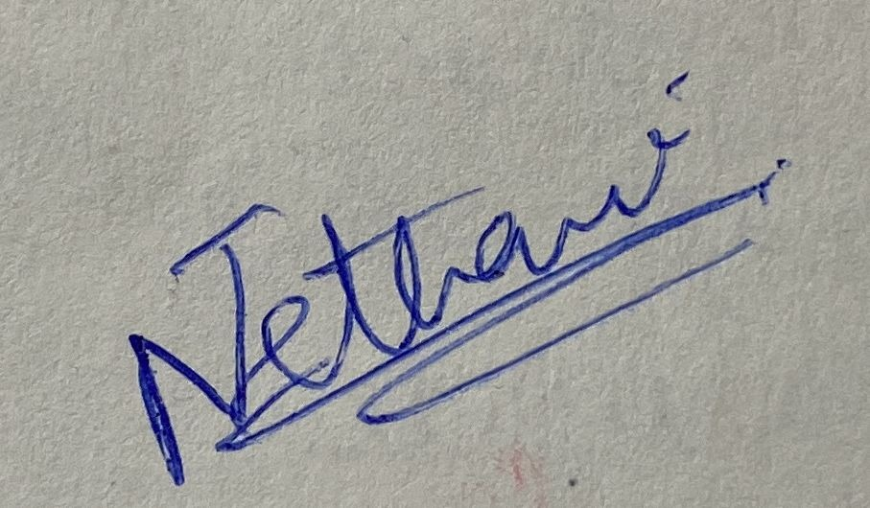

4.Arya Kurup 

(Name & Signature of Students with Date)

Abstract

Connect-Four is a [tic-tac-toe](https://mathworld.wolfram.com/Tic-Tac-Toe.html)-like two-player game in which players alternately place pieces on a vertical board 7 columns across and 6 rows high. Each player uses pieces of a particular color (commonly black and red, or sometimes yellow and red), and the object is to be the first to obtain four pieces in a horizontal, vertical, or diagonal line. Because the board is vertical, pieces inserted in a given column always drop to the lowest unoccupied row of that column. As soon as a column contains 6 pieces, it is full and no other piece can be placed in the column.

Both players begin with 21 identical pieces, and the first player to achieve a line of four connected pieces wins the game. If all 42 pieces are played and no player has placed four pieces in a row, the game is drawn.

Acknowledgement

We sincerely express indebtedness to our esteemed and revered guides Dr. M.Vijayalakshmi, the head of the AI-DS Department and Prof. Ajinkya Valanjoo of the AI-DS Department for their invaluable guidance, supervision, and encouragement throughout the work. Without their kind patronage and guidance, our project would not have taken shape.

We owe sincere thanks to all the faculties in the Department of AI-DS and Engineering for their advice and counseling from time to time.

Table of Contents

**Abstract**

**List of Tables**

**List of Figures**

**1. Introduction**

1.1. Introduction

1.2. Problem Statement

1.3. Objectives

1.4. Scope

**2. Literature Survey**

2.1 Literature/Techniques studied

2.2 Papers/Findings

**3. Analysis and Design**

3.1 Analysis of the system

3.2 Proposed Solutions

3.3 Design of the proposed system

**4. Results and Discussion**

**5. Conclusion and Future Work**

**References**

Introduction

Connect Four is a strongly solved perfect information strategy game: the first player has a winning strategy whatever his opponent plays. Initially, the game was first solved by [James D. Allen](http://fabpedigree.com/james/index.htm) (October 1, 1988), and independently by [Victor Allis](https://en.wikipedia.org/wiki/Victor_Allis) two weeks later (October 16, 1988). At this time, it was not yet feasible to brute force the game completely. Both solutions are based on rule based approaches in combination with knowledge databases. James D. Allen’s strategy[1](http://blog.gamesolver.org/solving-connect-four/01-introduction/#fn:1) was later published in a more complete book[2](http://blog.gamesolver.org/solving-connect-four/01-introduction/#fn:2), while Victor Allis’ solution was published in his thesis[3](http://blog.gamesolver.org/solving-connect-four/01-introduction/#fn:3). Later, with more computational power, the game was strongly solved using brute force resolution. [John Tromp](https://tromp.github.io/) extensively solved the game and published in 1995 an opening database providing the outcome (win, loss, draw) of any 8-ply position. John Tromp’s solver[4](http://blog.gamesolver.org/solving-connect-four/01-introduction/#fn:4) recently solved the 8x8 board in 2015. The final step in solving Connect Four is to compute the best number of plies before the end of the game in addition to outcome (win, loss, draw). [GameCrafters](https://www.ocf.berkeley.edu/~gamers/) from Berkeley university provided a first online solver[5](http://blog.gamesolver.org/solving-connect-four/01-introduction/#fn:5) computing the number of remaining moves to perform the perfect strategy. As well as Christian Kollmann’s solver build as a student project in Graz University of Technology.

Problem Statement

Connect-Four being a two-player mathematical 6x7 board game, can be solved strategically using a mathematical solution.

We are planning to make this game in such a way that the user plays

against the bot (i.e the computer). We plan to create a nearly perfect bot-with the help of various algorithms- that wins in almost all cases or draws in a worst case scenario.

Objectives

We intend to make a game in which the bot (i.e the computer) is able to intelligently play the game of connect four. The game involves deep enough strategies that make the game interesting from the point of view of invoking artificial intelligence. We intend to analyse the board to about 4 depths before making the move. This would involve the successive analysation of the strength of the computer as a consequence of effective moves. The graphics involved in the game would give us an insight into efficient handling of the graphics package. The usage of mouse makes the interface very user-friendly enabling him to be able to make his move at a click. The challenge also lies in playing the game at two levels and invoking the algorithm accordingly. If possible, we would like to make the game playable through networking as well.

Scope

The bot in the game helps increase the difficulty level which in turn challenges the user. The main objective is to create a bot which can figure out where to put coins in a connect four game. Given the casual nature of this game, the calculation time is limited to 20 seconds. The human player or bot will play first. We plan to create a nearly perfect bot-with the help of various algorithms- that wins in almost all cases or draws in a worst case scenario. This reduces the chances of the player to win.

Techniques Studied

For this Connect Four game we have studied and will be using various algorithms. One of the algorithms we have researched and studied about is the MinMax Algorithm.

Mini-max algorithm is a recursive or backtracking algorithm which is used in decision-making and game theory. It provides an optimal move for the player assuming that the opponent is also playing optimally.The Mini-Max algorithm uses recursion to search through the game-tree.The Min-Max algorithm is mostly used for game playing in AI. This Algorithm computes the minimax decision for the current state.

In this algorithm two players play the game, one is called MAX and other is called MIN.Both the players fight it as the opponent player gets the minimum benefit while they get the maximum benefit.Both Players of the game are opponents of each other, where MAX will select the maximized value and MIN will select the minimized value.The minimax algorithm performs a depth-first search algorithm for the exploration of the complete game tree.The minimax algorithm proceeds all the way down to the terminal node of the tree, then backtrack the tree as the recursion.

Findings

In 2007, Milton Bradley published Connect Four Stackers. Instead of the usual grid, the game features a board to place colored discs on. Just like standard Connect Four, the object of the game is to try and get four in a row of a specific color of discs.

In 2008, another board variation Hasbro published as a physical game is Connect 4. This game features a two-layer vertical grid with colored discs for four players, plus blocking discs. The object of the game is also to get four in a row for a specific color of discs.

A *SpongeBob SquarePants* version of the game was released in 2009 for the show's 10th anniversary. The rules are the same as the normal version; the chips have the faces of SpongeBob and Patrick on them.

Analysis of the system

Solving Connect 4 can be seen as finding the best path in a decision tree where each node is a Position. At each node the player has to choose one move leading to one of the possible next positions.

In practice exploring the full tree is most of the time untractable due to exponential growth of tree size with search depth. Most AI implementations explore the tree up to a given depth and use heuristic score functions that evaluate these non-final positions.

When the game begins, the first player gets to choose one column among seven to place the colored disc. There are 7 columns in total, so there are 7 branches of a decision tree each time. After the first player makes a move, the second player could choose one column out of seven, continuing from the first player’s choice of the decision tree.

First, if both players choose the same column 6 times in total, that column is no longer available for either player. It means that their branches of choice are reduced by one. Second, when both players make all choices (42 in this case) and there are still no 4 discs in a row, the game ends as a draw, and the decision tree stops. Finally, if any player makes 4 in a row, the decision tree stops, and the game ends.

Proposed Solutions

* Place in the middle column

If the player can play 1st, it is better to place it in the middle column. Since the board has 7 columns, placing the discs in the middle allows connection to go up vertically, diagonally, and horizontally. In total, there are 5 possible ways.

* Make traps for the opponent

One typical way of not losing is to try to block the opponent’s paths toward winning. For ex. preventing the opponent from getting a connection of three by placing the disc next to the line in advance to block it. This strategy also prevents the opponent from setting a trap on the player.

* Make a “7”

A 7 trap is a name for a strategic move where 1 positions his disks in a configuration that resembles a 7. With 3 horizontal disks connected to 2 diagonal disks branching off from the rightmost horizontal disk. The 7 can be configured in any way, including right way, backward, upside down, or even upside down and backward. This disk formation is a good strategy because it gives players multiple directions to make a connect 4.

Design of the proposed system

**Input:**

As soon as the user runs the program the game will start and there will be a option window asking the user for the following:

1) The player's name

2) Color choice of ball

3) The difficulty level he/she wants to play ( EASY, NORMAL OR DIFFICULT )

4) Who goes first

5) Exit

After the initial settings have been set by the user the game begins. The user would be allowed to click on the pointers positioned above each column.

**Output:**

On the click of the mouse in the specified column, the coin would be inserted in the appropriate location which is the lowest unoccupied slot. The computer would then analyse the game field and would then go to subsequent depths in order to be able to make the smartest move. After having decided on the move the computer would then insert the coin in the decided slot. At any stage the user will be allowed to pause or resume the game.

Result and Discussion

As per discussion with ma’am we confirmed the project topic, rules and regulation, prototype, libraries, algorithms for AI, environment in which we are going to do project. During discussion in team we came to know about minmax algorithm and references of the project.

Conclusion and Future Work

The program deals with artificial intelligence. The computer is required to use it's intelligence against each move by the user which will be dependent on the developed algorithm. The more the complexity and efficiency of the algorithm the better will be the moves made by the computer and will be tougher for the user to prove him/herself smarter than the machine.

The platform that will be used for developing the project will be PyCharm. We prefer PyCharm as the operating platform because of its ease of use and easy debugging abilities. We also make use of the inbuilt classes defined in Python's library and the various methods in them. We plan to use the Input Output functions and various packages for the graphical part of the program for **GUI** (Graphical User Interface).

References

* <https://medium.com/analytics-vidhya/artificial-intelligence-at-play-connect-four-minimax-algorithm-explained-3b5fc32e4a4f>
* <https://web.stanford.edu/class/aa228/reports/2019/final106.pdf>
* https://www.javatpoint.com/mini-max-algorithm-in-ai